Lesson 04 Demo 12

Configuring Azure Container Instances

Objective: To configure Azure Container Instances
Tools Required: Azure account with administrator access

Prerequisites: None

Steps to be followed:
- Configure Azure Container Instances

Step 1: Configure Azure Container Instances

- Click on + Create a resource after signing in to the Azure portal

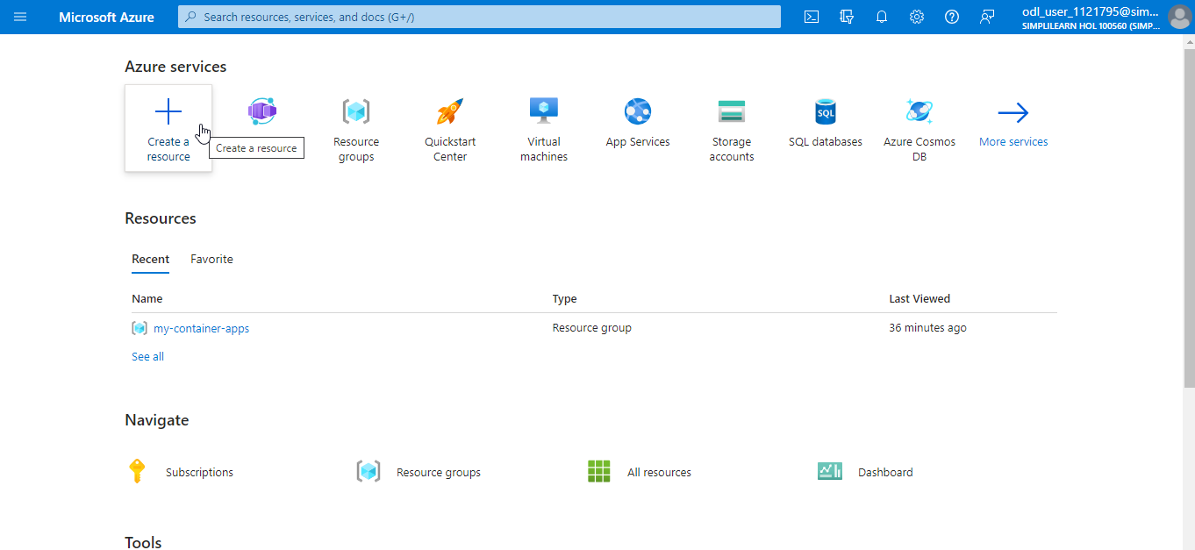

- Under the Categories, locate and click on Containers, then select Container Instances from the options displayed

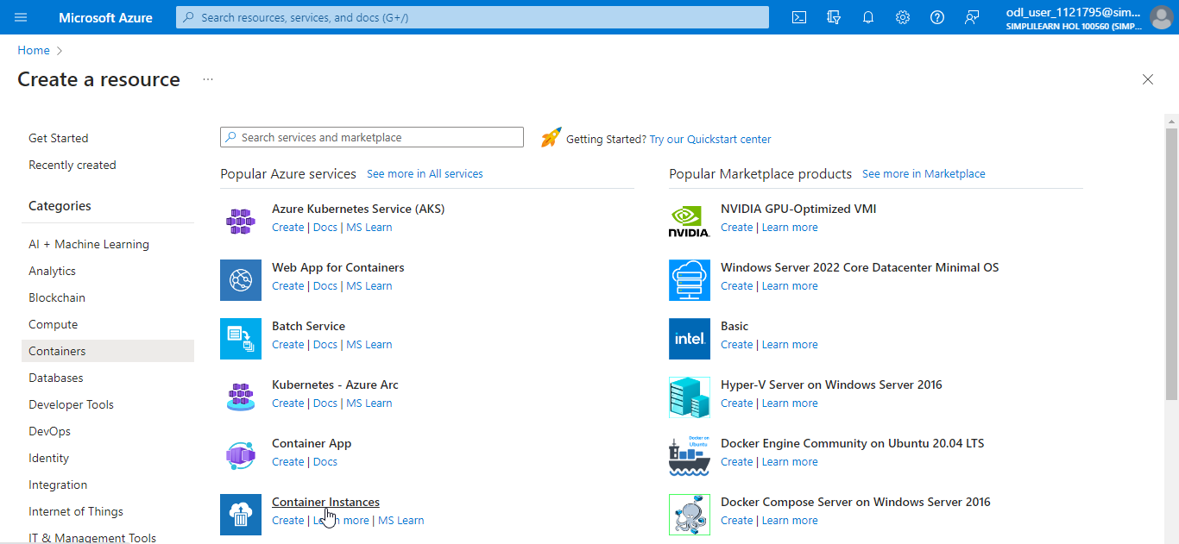

- On the Create container instance page, navigate to the Basics tab and click on Create new to create a new Resource group

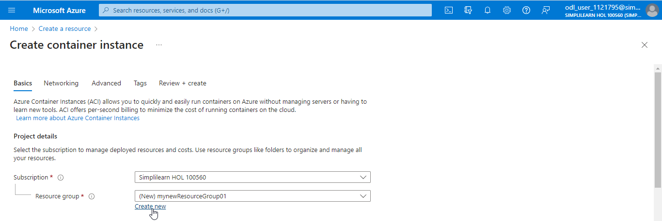

- Under Container details, provide the details as shown in the below screenshot

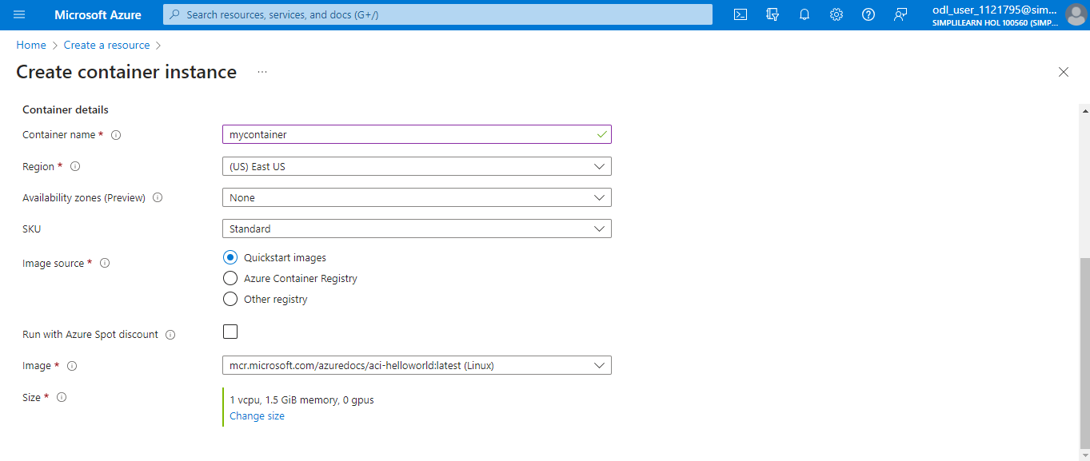

- Navigate to the Networking tab and provide the details as shown in the below screenshot

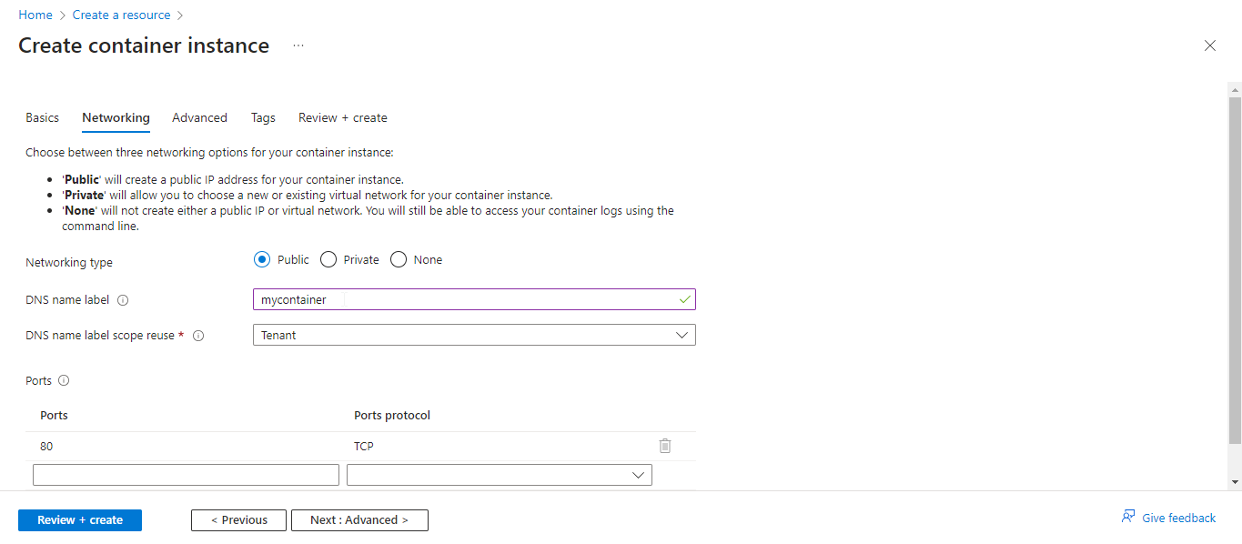

- Click on Review + create

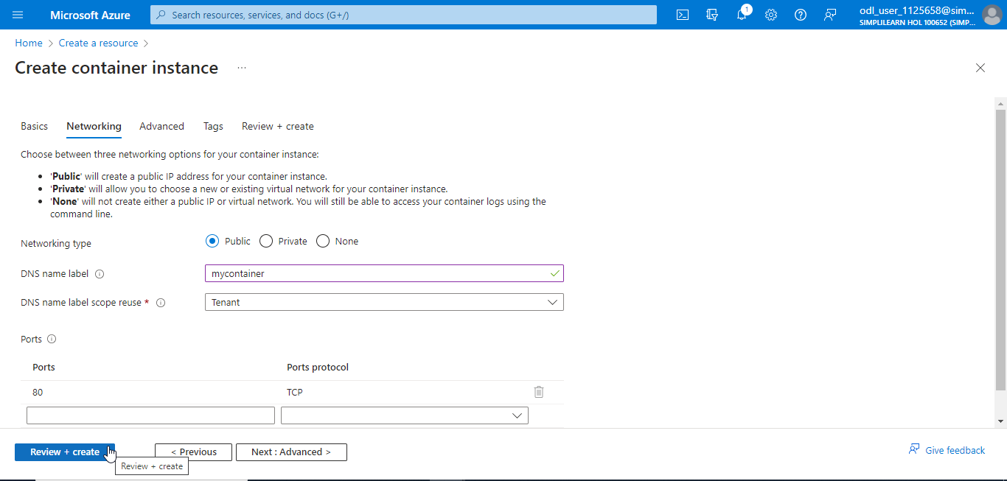

- Once the validation is passed, click on Create

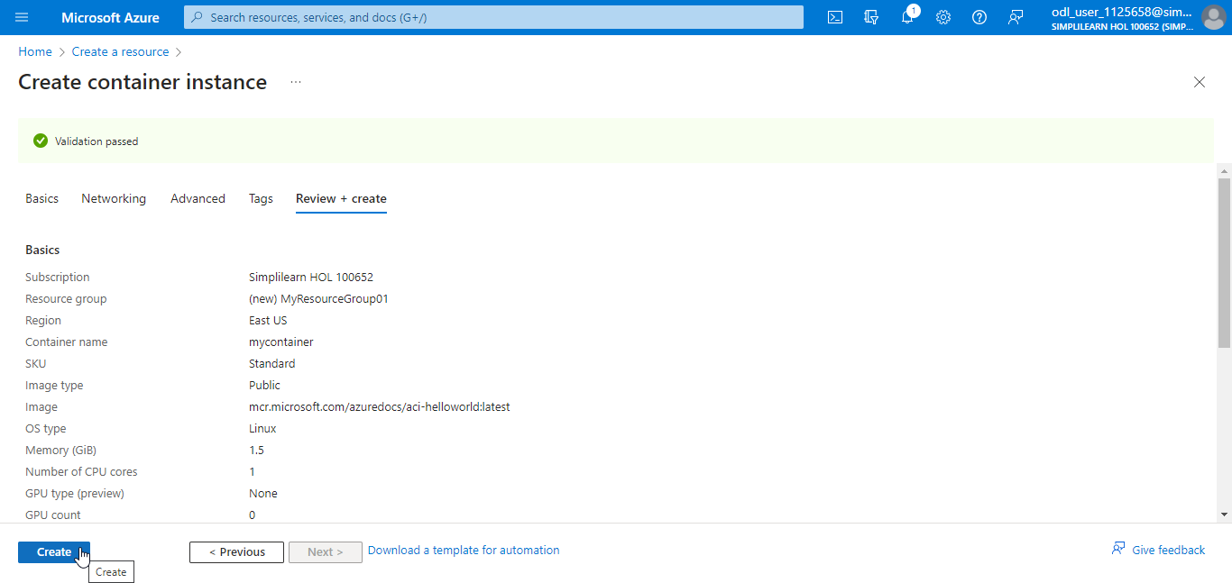

The Container Instance is created successfully.

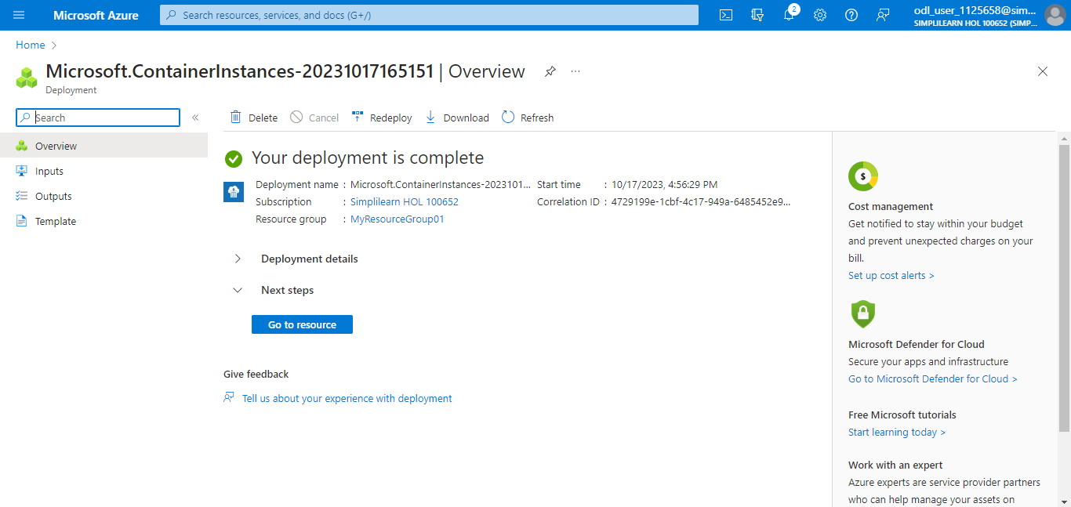

- Click on Resource groups and select the created resource group (myResourceGroup01)

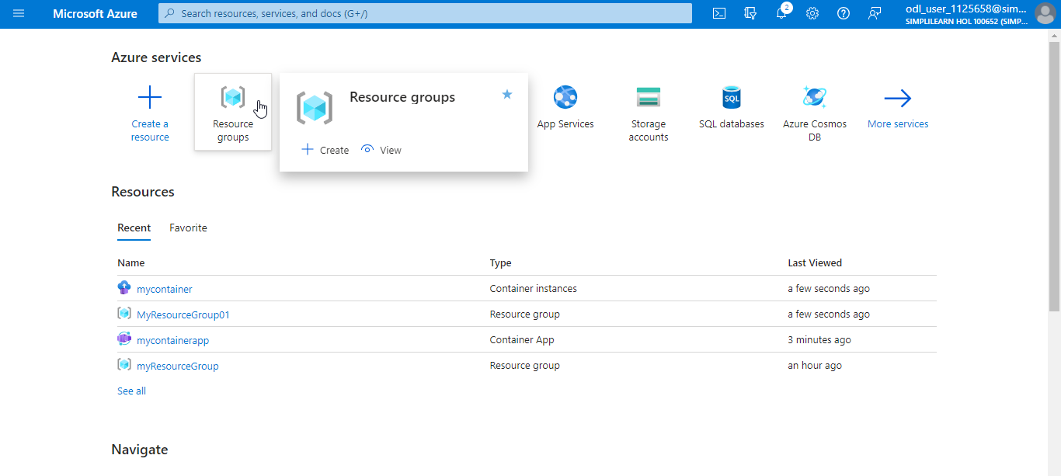

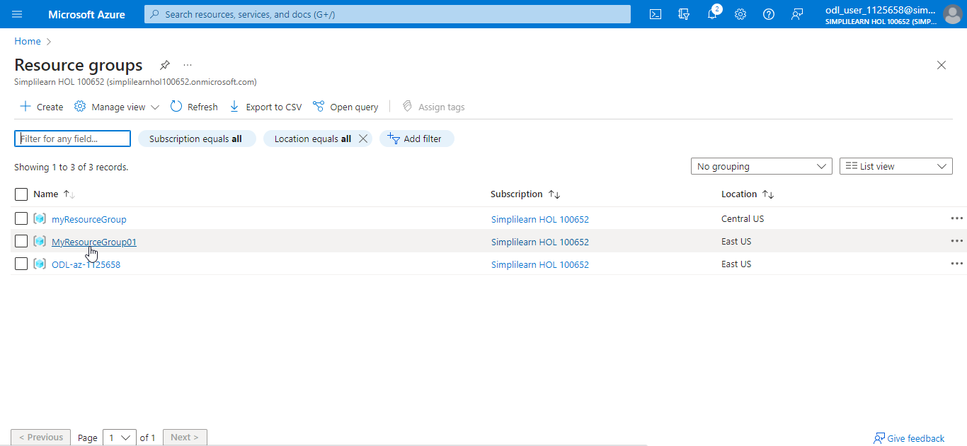

- Click on Overview and select the created Container Instances (mycontainer)

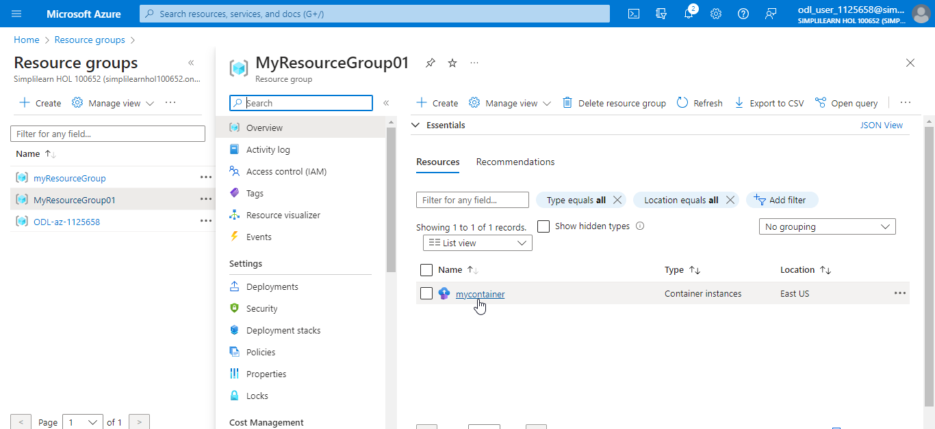

- Once the Status is Running, click on the FQDN link to launch the Azure Container Instances

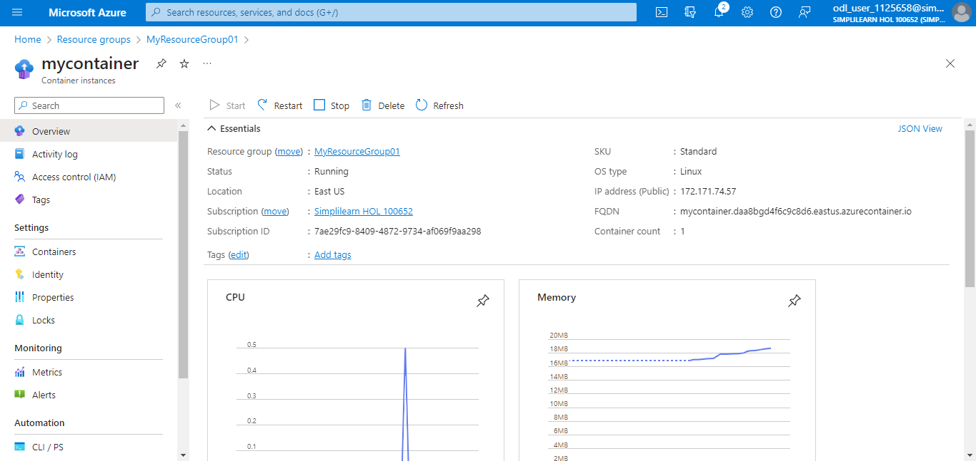

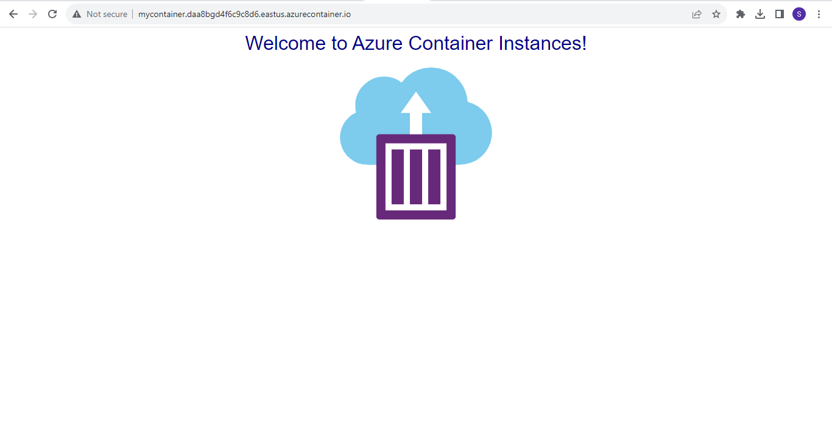

With this, you have successfully configured Azure Container Instances.

